Piloo Records & Productions Presents:

“ DISGUISE” by ADA ROVATTI
RELEASE DATE: JULY 22nd 2014
RADIO ADD DATE: JULY 21st 2014

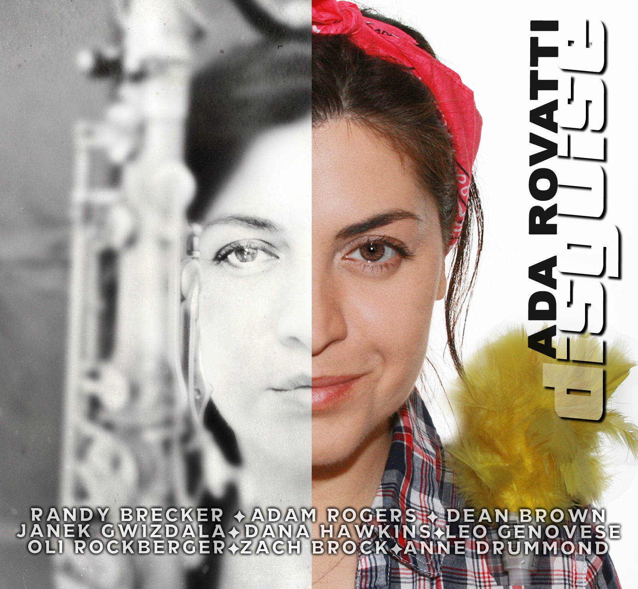
Ada Rovatti ‘s new work has been maturing over the last few years, since her last recording as a leader is dated 2009. As the cover and title suggest, this project explores all of Ada’s personalities and this kind of variety is a trademark of her writing and playing.
On this recording a stellar line up of musicians support the project. Guests like Randy Brecker, Adam Rogers, Dean Brown, Zach Brock, and Anne Drummond, all bring the music to inspired heights, and with the strong rhythmic support generated by Janek Gwizdala, Oli Rockberger, Leo Genovese and drummer Dana Hawkins, all the musicians deliver outstanding performances exploring the Jazz, Funk, Rock & Latin idioms.
This CD contains 7 originals tunes penned Ms. Rovatti, each one of them representing different sides of Ada’s love for music and two tunes that she rearranged for the recording: “Smile” by Charlie Chaplin, and borrowed from the rock repertoire, a cutting edge version of “Stairways to Heaven” by Led Zeppelin.

ABOUT THE ARTIST:

After studying at Berklee College of Music, Italian born saxophonist, composer and arranger Ada Rovatti moved to Paris before landing in New York City.
She performed and recorded with artists such as: Randy Brecker, Bob Mintzer, Victor Bailey, Aretha Franklin, Miroslav Vitous, John McLaughlin, Mike Stern, James Moody Jon Faddis, Don Alias, just to name few.
She also played on Randy Brecker’s Grammy winning CD “34th n’ Lex”– ESC Records (Best Contemporary Jazz Album 2003) & on the acclaimed CD by John McLaughlin “Industrial Zen” (2006)
She also appeared as a musician in the movie ‘Mona Lisa Smile’ featuring Julia Roberts.
She recently was part of the Brecker Brothers Band Reunion with whom she recorded a double DVD/CD released in 2014 on Piloo Records
As a band leader she has released 5 CDs: Ada Rovatti & The Elephunk Band – For Rent (2003),Under The Hat (2003) Airbop (2006) Green Factor (2009) & Disguise (2014)

PERSONNEL:
Ada Rovatti, Randy Brecker, Dean Brown, Adam Rogers, Zach Brock, Anne Drummond, Dana Hawkins, Leo Genovese, Janek Gwizdala, Oli Rockberger.

TUNES
1.Ghost Stories, 2. Alone In Traffic, 3.TBA , 4. Smile – Intro (sax solo),
5. Smile, 6. Moving Forward, 7. Halfway, 8.Tripping Step, 9.Stairway To Heaven, 10. Gentle Giant

Radio Promotion By Mitchell Feldman Associates / 706.550.0263 MitchellFeldmanAssociates@Charter.net

To schedule an interview please contact Piloo Records at 212-560-2561 or contact@piloorecords.com
For more information on this artist visit: http://www.piloorecords.com or For more information on this artist visit: http://www.adarovatti.com

